Here's a list of the fathers and former teachers we know their whereabouts:

*********************************************************
Fr Farren Ireland
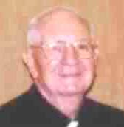
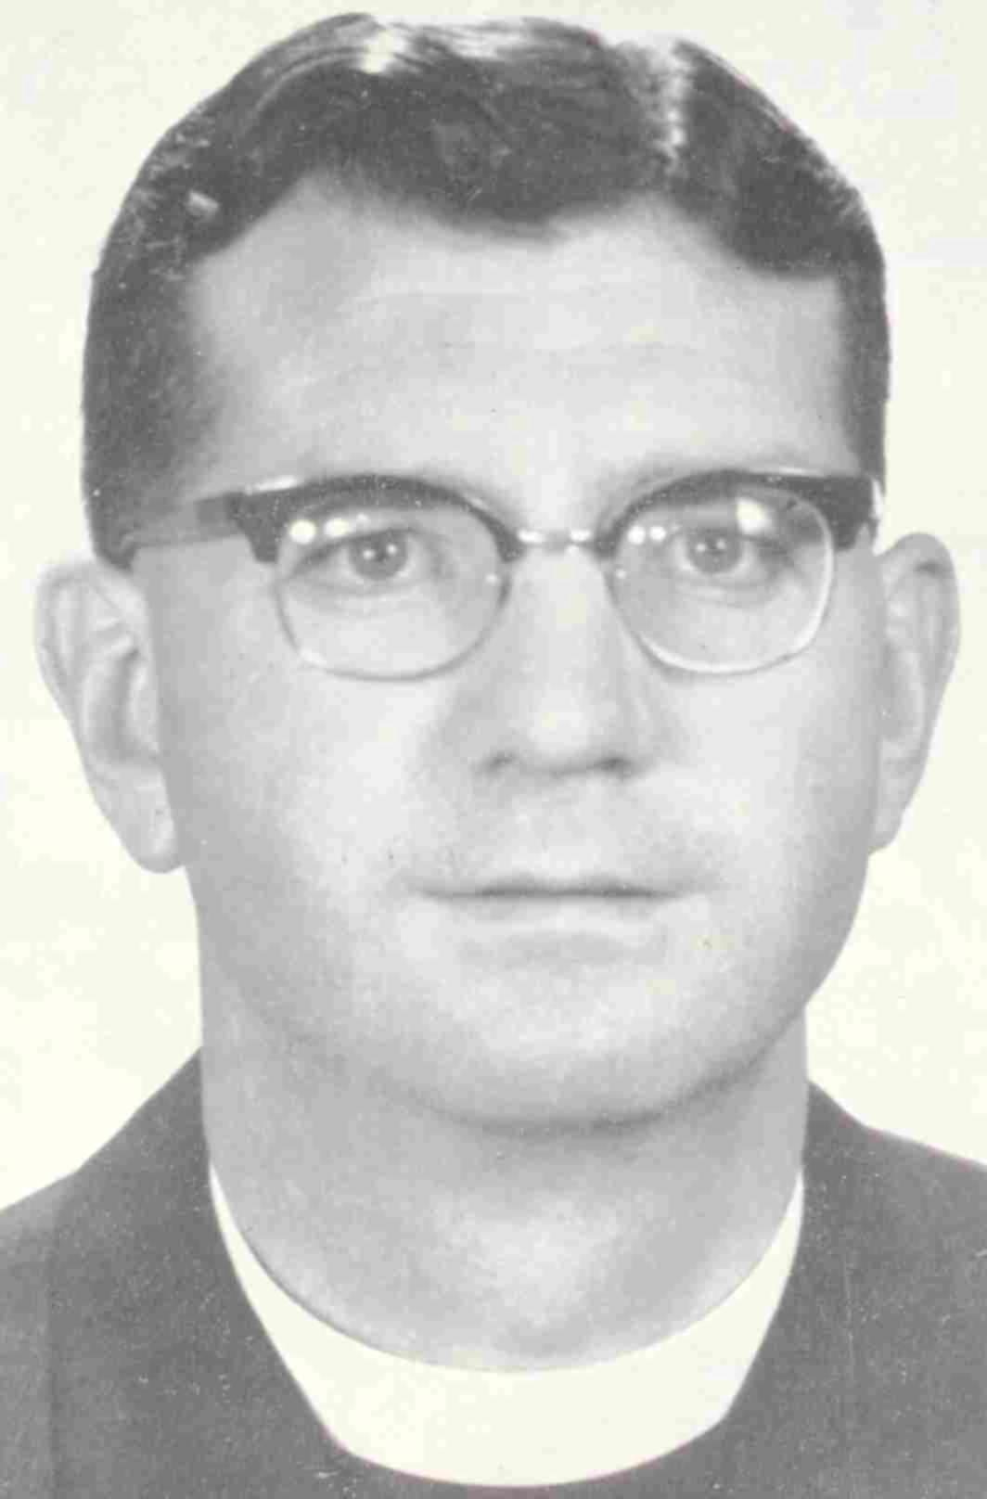
1961 1999

*********************************************************

Fr James England not as a Jesuit

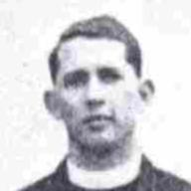
1962

*********************************************************

Fr Jones unknown got married

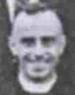
1959

*********************************************************

Fr Kane Hong Kong

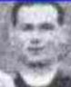
1961

*********************************************************

Fr Mallin Hong Kong

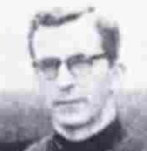
1963

*********************************************************

Fr O'Neill Singapore
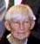
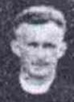
1961 2002

*********************************************************

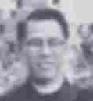
Fr Tseng Singapore
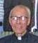
1960 2002

*********************************************************

Mr Chan Kwan Man Hong Kong

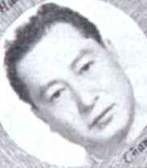
1957

*********************************************************

Mr Fung Kin-Fung USA

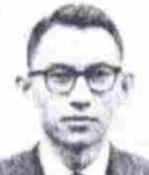
1962

*********************************************************

Mr Ho Chun-Yuen, Anthony Toronto
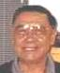
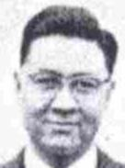
1962 2000

*********************************************************

Mr. Hou Hsiang-Dah USA

1959

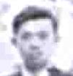
*********************************************************

Mr Hsi Chin-Tse, Nelson USA

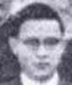
1961

*********************************************************

Mr. Hsueh Wei-Shiang, Wilson Toronto
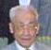
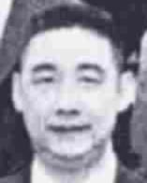
1963 2002

*********************************************************

Mr Hung Tai-Kong USA

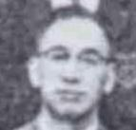
1957

*********************************************************

Mr Kong Chi-Kwan, Francis Hong Kong
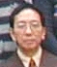
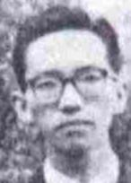
1961 2000

*********************************************************

Mr Lee Hoi-Chow, Hillary Hong Kong
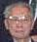
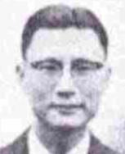
1962 2002

*********************************************************

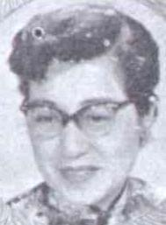

Ms Lee Tuen-Yung Hong Kong
1957 2002

*********************************************************

Mr Light Shirlien unknown

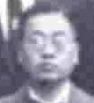
1960

*********************************************************

Mrs Ma-Wong Kit-Kwan Hong Kong

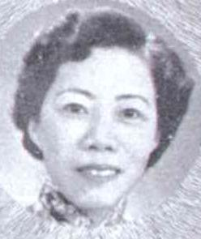
1957 2002

*********************************************************

Mr Sie Chung-Tien USA

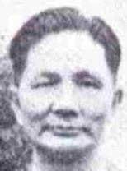
1962

*********************************************************

Mr Tam Chi-Sing, Laurence Toronto
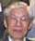
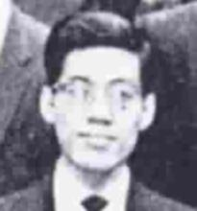
1963 2002

*********************************************************

Mr Wong Chin-Wah Hong Kong

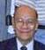
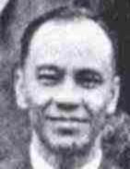
1962 2002

*********************************************************

