WYK 61 Grads - Greetings to Father Farren (updated Apr 27 12:10 am Toronto time)
************************************************************************
Dear Father Farren,

Time really flies. It has been more than forty-five years since we entered Wah Yan College, but the fond memories of those happy days are still vivid in our minds.

I still remember clearly that when I was in P.6 we won the overall C grade
championship in the inter-school athletic meet (by the way I was the champion in
high jump), and school treated the C grade athletic team members to dinner in the
canteen (the whampoa scrambled egg was one of the dishes and it tasted so good).
It was a very joyous occasion.

When we were in F5, you as headmaster encouraged us to be enumerators in the
Hong Kong census. It gave me a first and also wonderful working experience.
The F6 and F7 classrooms were in the secluded area below the canteen. Very so
often Father Chan, the discipline master then, charged down the stairs in order to
catch those naughty students for their disruptive behaviour, but always in vain
because they were very alert and acted innocently when he arrived. I feel very
sorry for Father Chan, and I understand his feelings and perhaps frustration as I
myself had also been a discipline master some twenty years later.

Somehow we the ignorant young kids transform, as in metamorphosis, into
mature adults and make contribution to the world in various ways. Thanks to
the nurture at WYK.

Best regards,

Fong Wang-bun (Apr 15, 2002)
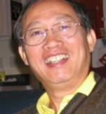
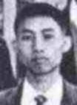
1961 2002

************************************************************************
Dear Father Farren,

I am so glad that I have this opportunity to say a few words to you. You
were my form master of 4C in 1959. I haven't seen you since leaving Hong
Kong after graduation.

I went back to our old school a few times but did not run into you. A
couple of times I strolled by and paused outside the Head-Master's office
at the far end of the right wing. I couldn't help remembering the few
times when I arrived late for classes. You people didn't treat tardy
students very nice those days. Not trying to look for an excuse, but I
had to travel a long way including crossing the harbour every morning.
As witnesses, I have Ho Ping-Kwong and Martin Lee who often took the
same ferry with me. By the way, this Martin Lee is the bad one, as I just
learned from these emails...sorry Martin.

Anyway, after climbing the long flight of stairs leading to the side
entrance, the first challenge was to pass your office without being
caught. It was difficult to tell through your windows whether you were
inside looking out or not. I can almost feel my pounding heartbeats now
as I dashed pass your office blindly 40 years ago. Well, I eventually
did get caught, but not by you. Not a bad achievement on my part as I
think about it now. However, I wonder was I really lucky that you never
saw me, or someone was showing mercy on that scared soul.

It is comforting to know you are resting in your homeland after so many
years of selfless service in the foreign lands. How fortunate are we to
have you and the other Jesuits came so far away to prepare us for the
world in our younger days. I wish your retirement years are full of
peace and happiness.

Sincerely,

Fok Kee-Sau (Apr 16, 2002)
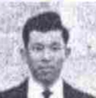
1961

************************************************************************
With best wishes from Yum Sing Kung (Francis) (Apr 12, 2002)
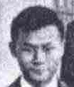
1961

************************************************************************

Dear Father Farren,

I was so amazed that you remembered me when you were in Toronto in 1999 for
the Wah Yan, Kowloon 75th Golden Jubilee reunion. You still remembered that
there were two "Martin Lee"s in your class. In case you cannot tell the
difference between the two Martin Lee's, just remember that I am the good
one - just kidding.

I went back to Hong Kong last year in October after 21 years' of absence. I
was going to look you up at Wah Yan, Hong Kong, but was told that you had
already left for Ireland for good. However, I had a chance to visit Wah
Yan, Kowloon. The trip brought back a lot of good memories - with you in
the midst of most of them.

Dominus vobiscum

Martin LEE (Apr 6, 2002)

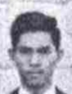
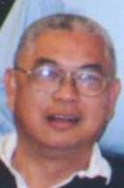
1961 2001

************************************************************************
Dear Father Farren,

Please give us your telephone number, email address and postal address in
Ireland. 2 Years ago I was in Ireland on a PDA project developed in Ireland.
I find Ireland a peaceful country and becoming very prosperous in the IT/
electronic business. I suggest our Wah Yan friends to visit Ireland when we
are in Europe and pay you a visit. We also have all reached the age of 60 and
we still need your advice about this life and afterwards. I want to say how
grateful I am for all the Jesuit fathers I have met in Wah Yan.

With email, you and us can always keep in touch. We can send photos with
voices and songs to you on the personal side, I am still working in my
business. Web site: www.aaa.com.hk. I plan to retire at 75. My wife & I
just celebrated our 30 years wedding anniversary. My two sons are graduated
from the universites and working in Hong Kong.

My mobile phone is (852) 91956856, office tel is (852) 29510146.

Happy Retirement to father Farren!
Merry re-union to the Wah Yan boys in Toronto!
Hong Kong re-unions are organized by Camelo Leung & I am most grateful for
his efforts.

Love From

Clement Lee Wen Hao (Apr 11, 2002)

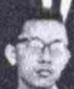
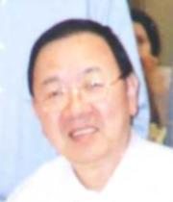
Email : clement.lee@aaa.com.hk
1961 2001

************************************************************************

