WYK 61 Grads - Greetings to Father Farren (updated Apr 27 12:10 am Toronto time)
************************************************************************
<< At Fong-Lun's request, this message is forwarded to Father Farren >>

"Remembering Our Former Teachers"

Dear Hin Shing,

I play Bach, Beethoven, Handel and Vivaldi pieces all the time. I have more
than enough of their music pieces to play right now. Anyway, thanks a lot
for your offer to burn some CDs for me. I hope to discuss in length about my
musical repertoire to all of you dear and beloved old pals in Toronto later
this month. I am exceedingly flattered to have so many Wah Yan guys come to
the reunion table. Shall we refresh our memory about Father Chan, Father
Kennedy, Father O'neill, Father Farren, Father Tony, Father Cryan and Father
Doody? To me, they are all clean-cut and dedicated Jesuit Priests coming
all the way from Ireland to serve the whole bunch of we Chinese guys in Hong
Kong. I appreciate their sacrificial love from the bottom of my heart!

Thinking of you and your family as always,
Yu, Fong Lun Philip & Kelly Wong (wife) (Apr 5, 2002)
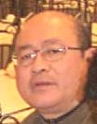
1961 2002
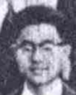
************************************************************************

Dear Fr. Farren,
You were my principal when I graduated from matriculation in 1963 to go to
the University of Hong Kong. You also taught us arts students B.K. in form
six, I think. We studied St Luke (Knox version), and partly from your urging
I committed most of chapter one to heart, and can still rattle off a few lines!
And I was not a Catholic. I still am not one, but am grateful to the Jesuits for
the imparting of biblical knowledge such that I am aware of the teaching of a
great religion and have been guided consciously or unconsciously by its
doctrines. The sense of both Catholicsim and religious tolerance that infused
the school, and the fathers' kindness to all are aspects of Wah Yan that make
it so influential in my own upbringing, and I thank you for it.
I would like to join my many good classmates to wish you the best in health
and work in the coming years in your home country.
You remember Mr. Patrick O'Flanagan? He was my literature teacher and mentor,
and I would like to remember him in this greeting although he passed away some
years ago.
Yours respectfully,

Yu Fong-ying (1955-63, WYK)
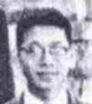
Vancouver (Apr 15, 2002)
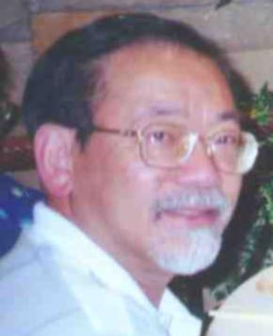
1961 2000

***********************************************************************
Hi, Dear Fr Farren,

Long time no see.

I trust you have no problem remembering me, as we saw each other for good many years when we played soccer in Wah Yan on Saturday afternoons with Cheung Siu Keung, Ng Chun Bong, Lai Ming Chung, Leung Koon Chuen, Tony Cheung Chi Tung and all that until the swimming pool was put up at one end of the soccer pitch. Of course, you were playing your tennis.

In any case, I attach a 'funny looking' recent picture of my to refresh you. (It might confuse you even more as I may not look quite like that in your memory.)

Any way, it was a bit sad that I didn't get to say good-bye to you before you went back to Ireland for good. (I heard that from Fr Deignan quite a bit later.) I hope this short note will find you in good health and that you are enjoying your retirement.

I am still in HK, (working at the HK Polytechnic University), seeing the old Wah Yan class/school mates once in a long while, when someone comes in town and when someone (like Carmelo Leung and Albert Lam Kwong Yu) is kind enough to organize. We are all getting a bit old now. Eating is about the only thing we can do together. No more football like in the good young days. But it certainly is great to be together and talk about the old times as well as the more recent affairs. There is always much to talk about in HK - the politics, the Government, the education, the mainland, Wah Yan ....

Previously I spent more time in Toronto when my family lived there. Since their return to HK a couple of years ago, I go there roughly once a year on business trip and catch up with the Wah Yan boys, particularly the '61ers and Wong Hin Shing. I am thankful to see so many classmates still in good health and well established in their respective fields. I might go back in the coming July/August time.

Well, I have to go now. Please do drop us a few words if you would. Try email, it's a lot of fun and we all can read it very very quickly.

Please do keep well and take care.

Fondly,

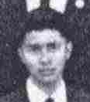
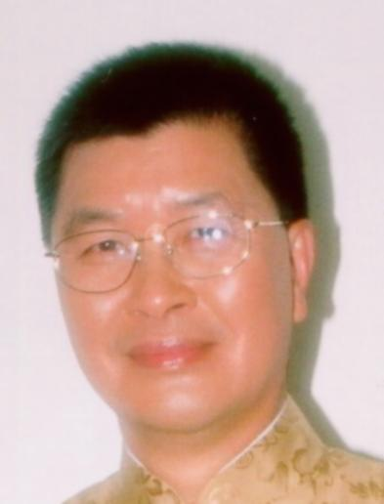
Richard Li (Apr 22, 2002)

1961 2002
***********************************************************************

Dear Fr. Farren,

It's time to reflect how much the Wah Yan Jesuits have done for us and our
families during the stages of growing up from "naughty teenagers" to mature
and successful men everywhere in the world . I want to send special regards
to you even after your retirement back to Ireland. I still remember the time
you were the Principal and I was normally a good decent student in Wah Yan.

You were the one who sent me to detention for the first and last time in my
life, because I was caught playing outside the Lower 6 classroom during
recess time. This was traumatic, but I learnt so much from this.

No matter what, my respect towards you and the other Jesuits remain the same all these
years. What a fond memory we have our acquaintances with you.

My best regards,

Stephen Lam (Apr 22, 2002)
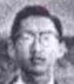
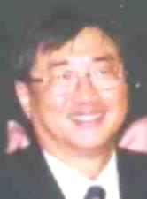
1961 1999

************************************************************************

Dear Fr. Farren,

I am Andrew Man, a relatively quiet guy of the 61 grads. I don't think you
remember me but it is ok. I just want to say how much I have used you, and
other Jesuit Fathers, as role model in my past 25 years as a teacher at a
university. I have always admired and appreciated the Fathers for coming a
long way to Hong Kong to educate us, sacrificing your ties with your family
and your own motherland. I pray to God that you have a wonderful retirement
in Ireland, a reward you deserve so much.

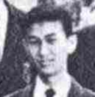
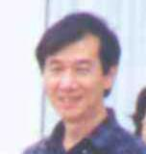
Andrew Man (Apr 22, 2002)
1961 1999

************************************************************************

