WYK 61 Grads - Greetings to Father Farren (updated Apr 30 09:35 am Toronto time)
************************************************************************
Dear Father Farren,

During my recent visit to Hong Kong, I tried to look you up at Wah Yan Hong
Kong, but I was told you have gone back to Ireland on your retirement.

On the occasion of the 1961 graduates of Wah Yan, Kowloon holding their
re-union gathering in Toronto, I would like to join my fellow school mates
and teachers in sending you our warmest regards, and to wish you a long and
happy retirement.

Thank you, Father, for teaching and taking care of us during our days at Wah
Yan, and to continue to provide us with comfort, support and your prayers
especially at a time of need. My daughter, Robina, whom you met in Hong
Kong has asked me to say a special hallo.

God Bless.

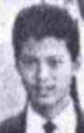
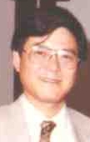
Harry Aitken (5 April 2002)
1961 1985 (?)

************************************************************************
Father Farren:

I meant to say a few words earlier, but the Hospital I work for is
undergoing an inspection and we in Human Resources have a lot to prepare
for, and so I'm late with this.

If you remember me at all, which I doubt, my Chinese name is Siu Lee; I was
in your Form 6 (A?) class in 1961-62, one of those nondescript fellows who
was good at neither academics nor sports (although I have retained my
passion for soccer all these years, and I am a great rooter for the
Republic of Ireland team which I believe will give a better account of
themselves in the World Cup than the English).

Since I left Hong Kong in November 1962, I have lived in the San Francisco
Bay Area (I can hardly believe it's been almost 40 years), am married, have a
daughter and a grandson who is turning four in July. All these years my Jesuit
education (at Wah Yan Kowloon and the University of San Francisco) has
stood me in pretty good stead: whatever English I learned I learned at Wah Yan.

I did come back to Hong Kong for a visit last May, and my wife and I took a
taxi to the school for a look-around. Unfortunately it was a holiday, and there was
no one about, but it turned out to be a very emotional occasion for me.

May I take this opportunity to send you my best wishes, and my heartfelt
thanks. Please feel free to write and keep me up to date.

Roderick Siu Lee Auyang (Apr 11, 2002)

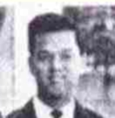
1961

************************************************************************
YEAH, so happy to read all these responses...4D, Fr. Farren, Your face with
the perpetual smile reminds me the happy daysof WYC. Soccer, classical
music gang, that's what make me to-day. So, as far as I'm concerned, we are
still your students, like forever. May the spirit be with us as always.
Also, the 3 recent pictures bring back a lot of memories, especially Mr. Tam,
my first physics teacher, and Fr. O'Neill, form master of 2D, the handsome
gentle pianist. Please keep it up, everyone!

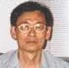
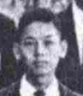
From, Yiu Man Chan (Apr 11, 2002)

1961 2000

************************************************************************
Dear Fr Farren,

I attended Wah Yan Kowloon from 1961-63, and I have very fond memories
of the experience. You were the principal at the time, and also taught religious
studies. I want to thank you and the Wah Yan College for the excellent education
I received which has sustained me for the past 40 years.
With best wishes,

Peter Chang (Apr 19, 2002)

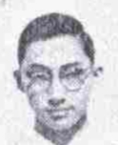
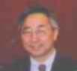
1962 2001

************************************************************************
Dear Father Farren:

I don't recall my years at Wah Yan with a great deal of pleasure. I remember a
great urge to fit in and a deep despair of ever doing so. It wasn't until after my
university days that I finally came to feel at peace with myself and the world
about me. I could not have been an easy boy to deal with. Yet, shining through
those days of insecurity and uncertainty, is the support and the comfort that my
teachers and friends at Wah Yan gave me, and especially the sacrifice and
dedication of my Jesuit teachers who had come all the way from Ireland. I will
always be grateful for that, and in my heart there will always be warmth for
Jesuits and for the Irish! Whenever I meet someone from Ireland, regardless
of their religion, I cannot resist bringing up my indebtedness to my teachers at
Wah Yan.

With love and respect, and gratefully,

Bob Chen, Wah Yan Kowloon Class of '61 (Apr 12, 2002)
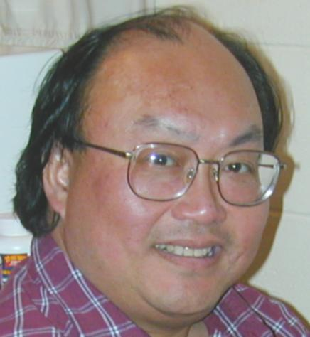
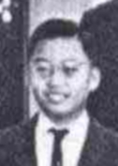
1961 2002

************************************************************************

